M.06 HISTAMINE, SEROTONIN AND THE ERGOT ALKALOIDS
DR. THERESE TOLENTINO I OCTOBER 6,2025
- INTRODUCTION 1
- Autacoids 1
- Characteristics of Autacoids 1
- Major Classes of Autacoids 1
- Biological Action of Autacoids 1
- HISTAMINE 2
- Distribution of Histamine 2
- Storage and Release of Histamine 2
- Histamine Receptors Subtypes 3
- Clinical use of Histamine 3
- ANTIHISTAMINES 3
- Inverse agonists 3
- Classes of H1 receptor blockers 4
- Other clinical application of antihistamine 5
- SEROTONIN AND TREATMENT FOR DEPRESSION 6
- Serotonin 6
- Serotonin synthesis and metabolism 6
- Serotonin in relation to depression 6
- Selective serotonin reuptake inhibitor (SSRIs) 6
- Non-pharmacologic interventions 7
- SEROTONIN 8
- ERGOT ALKALOIDS 9
- REFERENCES 10

CASE STUDY:
A healthy 45-year-old physician attending a reunion in a vacation hotel developed dizziness, redness of the skin over the head and chest, and tachycardia while eating. A short time later, another physician at the table developed similar signs and symptoms with marked orthostatic hypotension. The menu included a green salad, sautéed fish with rice, and apple pie. What is the probable diagnosis? How would you treat these patients?

- This patient demonstrates typical symptoms and signs caused by histamine. Fortunately, neither patient in this episode of food poisoning had significant laryngeal edema or bronchospasm. Certain types of fish, if improperly preserved, contain large quantities of histamine, due to the conversion – by the bacteria contaminating the muscle tissue of histidine to histamine. If consumed in sufficient amount, enough histamine can be absorbed to cause the clinical picture described.
- This syndrome is termed scombroid poisoning (Scombridae family of fish is most commonly associated with this toxicity).
- Treatment with maximal doses of histamine blockers, especially H1 blockers, is usually sufficient to control the symptoms.
- Because this is not an allergic reaction, administration of epinephrine is not necessary unless hypotension or airway obstruction is severe.
- It is not an allergic reaction therefore there is not an anaphylaxis. So, we will not use Epinephrine, which is a drug of choice for anaphylaxis, instead we will be maximizing the use of antihistamines.

- INTRODUCTION
- AUTACOIDS/AUTOCOIDS
- Endogenous substances with complex and pathophysiology functions.
- Have potent non-autonomic pharmacologic effects when administered as drugs.
- Do not fall into traditional autonomic groups.
- Do not act on cholinoreceptors or adrenoreceptors but have powerful pharmacologic effects on smooth muscle and other tissues.
- Locally produced and locally expressed factors that affect physiology.
- Most important amine autacoids:
- Histamine
- Serotonin
- Ergot alkaloids are NOT classified as autacoids but interact with serotonin receptors.
- Commonly encompasses:
- Histamine
- Serotonin
- Prostaglandins
- Vasoactive peptides

- CHARACTERISTICS OF AUTACOIDS
- Biologic factors that act like hormones but are not hormones.
- Hormones are delivered via the blood circulation into the area where they are needed.
- Their site of synthesis for hormones is at a distance from the site of its action.)
- Site of action is near the site of synthesis (not produced externally).
- Have brief duration of activity
- Act near the site of synthesis
- Not blood borne (locally produced)

- MAJOR CLASSES OF AUTACOIDS

CLASS | EXAMPLES
BIOGENIC AMINES | Histamine  Serotonin or 5-HT
PHOSPHOLIPID DERIVED | Prostaglandin (Eicosanoid)  Leukotrienes  Thromboxanes  (Eicosanoid and Leukotrienes are derived from the metabolism of Arachidonic Acid usually in the lipoprotein membrane.)
POLYPEPTIDES | Angiotensin  Kinins (Bradykinin and Kalikerin)  (Bradykinin is a mediator for pain which is considered an autacoid).
Table 1. Major Classes of Autocoids.

- BIOLOGIC ACTIONS FOR AUTACOIDS
- Modulation of the activity of:
- Smooth muscles (Airway bronchoconstriction)
- Blood vessels (Tunica media = vasoconstriction)
- Glands (GI Tract)
- Nerves
- Platelets
- Other tissues
- HISTAMINE
- Small molecules produced in our bodies by decarboxylation of the amino acid Histidine by Histidine Decarboxylase.

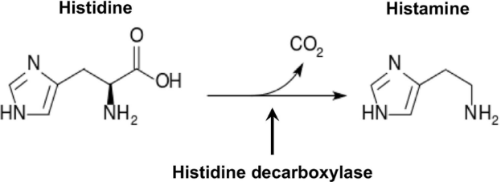
Figure 1. Histamine Synthesis
- Triple response (Wheal, Flush and Flare)
- Classic demonstrations:
- Redness
- Swelling
- Itch
- Pain

- DISTRIBUTION OF HISTAMINE
- Most tissue histamine is sequestered and bound in granules (vesicles) in mast cells and basophils.
  - Redness
  - Histamine content of many tissues is directly related to their mast cell content.
  - Mast cells and basophils are like containers for histamine.
  - Mast cells are especially rich at sites of potential tissue injury (nose, mouth, feet, internal body surfaces, and blood vessels (pressure points and bifurcate points).
- Non-mast cell histamine is found in several tissues.
  - BRAIN
    - Function as neurotransmitter for neuroendocrine control, cardiovascular regulation, thermal and body weight regulation, and arousal.
  - ENTEROCHROMAFFIN-LIKE CELLS (ECL)
    - Fundus of the stomach.
    - Release histamine is one of the primary gastric acids secretagogues.
    - Functions to activate the acid-producing parietal cells of the mucosa.

- STORAGE AND RELEASE OF HISTAMINE: DIFFERENT MECHANISM
B1. | IMMUNOLOGIC RELEASE
- AKA Immediate allergic reactions or Type 1
- When an allergy-prone individual for the first time comes into contact with an allergen (e.g. pine tree pollen), their B-cells will be activated and form plasma cells that produces large amounts of pine tree immunoglobulin-E antibodies.
  - IgE Antibodies firmly become attached to the surface of mast cells.
  - When the person again comes in contact with pine tree pollen, the binding of the allergens on the IgE will trigger the mast cells degranulation.

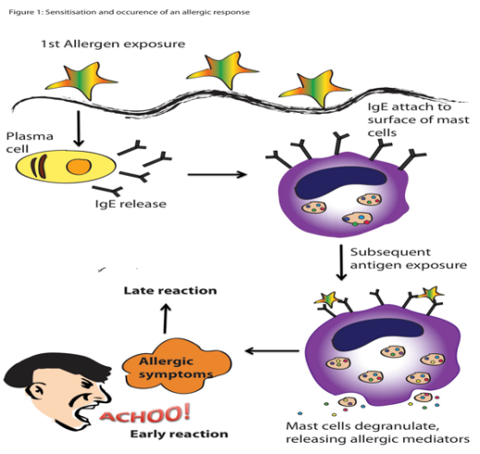
Figure 2. Sensitization and Occurrence of an Allergic Response.
Lifted from the Lecturer’s PowerPoint.

- Sensitization Phase to Allergic Reaction
  - Early phase: Histamine (main mediator)
  - Late phase: More potent mediators

EXAMPLES OF DISORDERS CAUSED BY IMMEDIATE HYPERSENSITIVITY
CLINICAL SYNDROME | CLINICAL AND PATHOLOGICAL MANIFESTATIONS
Anaphylaxis  (May be caused by drugs, bee sting, food, vaccines) | - Fall-in BP with or without urticaria after exposure to a known allergen. Hypotension is caused by vasodilation (distributive shock).  - Airway obstruction is caused by laryngeal edema.  Most severe form of  Type I Hypersensitivity reaction.  DOC: Epinephrine
Bronchial asthma | - Airway obstruction caused by bronchial smooth muscle hyperreactivity  - Inflammation and tissue injury caused by late-phase reaction.
Allergic rhinitis (Hay fever) | - Inflammation of the upper airway mucosa, turbinate, sinuses resulting in increased mucus secretion, sneezing, itchiness, and obstruction.
Food allergies | - May manifest as urticaria, angioedema of the upper airways, or abdominal pain and diarrhea by increased peristalsis due to contraction of the muscles.
Table 2. Immediate Hypersensitivity Disorders.

B2. | TISSUE INJURY
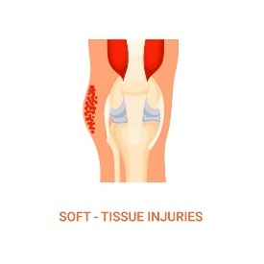
During tissue injury

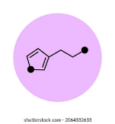
Damaged mast cells release chemical mediators (histamine)


Affect blood vessels and nerves in the damaged areas.

Figure 3. Tissue Injury

B3. | DRUGS AND FOREIGN CHEMICAL COMPOUNDS
- Compounds found in venoms, antibiotic dyes, and alkaloids (morphine).
- After release, histamine exerts effects by binding to various types of histamine receptors found on many cell types in the body.

- HISTAMINE RECEPTOR SUBTYPES

 | DISTRIBUTION | POST RECEPTOR MECHANISM | PARTIALLY SELECTIVE AGONIST | PARTIALLY SELECTIVE ANTAGONIST/  INVERSE AGONISTS
H1 | Smooth muscle  Endothelium  Brain | Gq  IP3  DAG | HISTAPRODIFEN | MEPYRAMINE  TRIPROLIDINE  CETIRIZINE
H2 | Gastric mucosa  Cardiac muscles  Mast cells  Brain | G5  cAMP | AMTHAMINE | CIMETIDINE  RANITIDINE  TIODINE
H3 | Presynaptic auto receptors and heteroreceptor  Brain  Myenteric plexus  Other neurons | Gi  cAMP | R-ALPHA METHYL-HISTAMINE  IMETIT  IMMEPIP | THIOPHERAMIDE  IODOPHENPROPIT  CLOBENPROPIT  TIPROLISANT  PROXYFAN
H4 | Eosinophils  Neutrophils  CD4 T cells | Gi  cAMP | CLOBENPROPIT  IMETIT  CLOZAPINE | THIOPERAMIDE
Table 3. Histamine receptor subtypes.
REMEMBER!
H1 and H2 receptors
are targets of clinically useful drugs.

C1. | H1 RECEPTORS
- Expressed primarily on vascular endothelial cells, smooth muscle cells, brain, and peripheral nerve endings.
- Mediate mainly inflammatory and allergic reactions.
- Effects of histamine when bound to H1 Receptors:
- Histamine binds to vascular endothelial receptors → blood vessels dilate → more permeable → REDNESS AND EDEMA.
- Histamine binds to smooth muscle receptors (located in the bronchioles) → BRONCHOCONSTRICTION.
- Histamine binds to H1 Receptors in the brain → promote WAKEFULNESS AND APPETITE SUPPRESSION.
- Histamine may act as a neurotransmitter in the CNS.
- Histamine-mediated stimulation of the peripheral nerve endings → ITCH AND PAIN SENSATION.
LOCATION | EFFECTS
Vascular endothelial receptors | Redness and Edema
Smooth muscle receptors | Bronchoconstriction
Peripheral nerve endings | Itch and Pain sensation
Brain | Wakefulness and Appetite suppression
Table 4. Histamine 1 Location and Effects
C2. | H2 RECEPTORS
- Expressed mainly in the gastric parietal cells
- Histamine binding on the gastric parietal cells will increase gastric acid secretion.

- CLINICAL USE OF HISTAMINE
- No therapeutic applications.
- Drugs that block its effect at H1 and H2 receptors are very important in clinical medicine.
- No antagonists for H3 and H4 (still in the experimental phase) are currently available in use since they are still being investigated for safety and efficacy.

- ANTIHISTAMINES
- Drugs that block the action of histamines.
- Act as INVERSE AGONIST.
- Bind to the H1 receptor on a target tissue and stabilizes its INACTIVE conformation → leading to inhibition of histaminic actions and gradual relief of allergy-related symptoms: inflammation, itching, runny nose, sneezing.

- INVERSE AGONISTS
- Typically, in the absence of ligand (partner molecule), a receptor might be fully active or completely inactive.
- However, many receptor systems exhibit some activity in the absence of a ligand, suggesting that some fraction of the receptor is in an active state (CONSTITUTIVE ACTIVITY).
- Unlike full agonists, they stabilize the inactive receptor (R)form and cause the active receptor (Ra) to convert to inactive form (Ri).
  - Decreases the number of activated receptors to below that observed in the absence of the drug.
  - Intrinsic activity is less than zero, reverse the activity of the receptors, and exert the opposite of the pharmacologic effect of the agonists.
  - Bind to the receptor without affecting receptor signaling: "neutral" or “silent" antagonists.

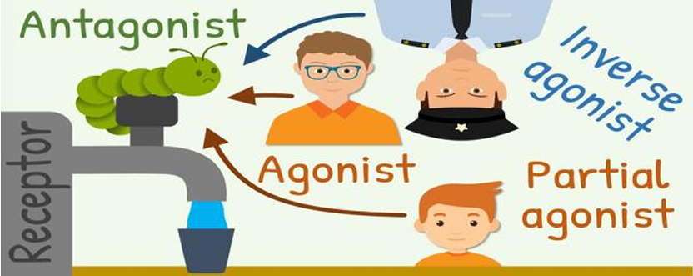
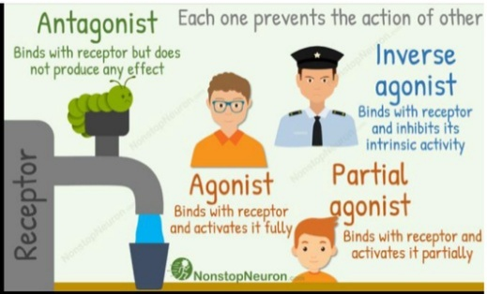
Figure 4. Receptor Types

- CLASSES OF HISTAMINE 1 RECEPTOR BLOCKERS
B1. | FIRST GENERATION H1
- Structure consists of 2 aromatic rings connected to a substituted ethylamine group.
- Due to the lipophilic structure, can cross the blood-brain barrier → sedation and potentially impaired cognitive function.
- Relatively, have poor H1 receptor selectivity; They are capable of occupying other receptors such as cholinergic, alpha-adrenergic, and serotonin receptors.

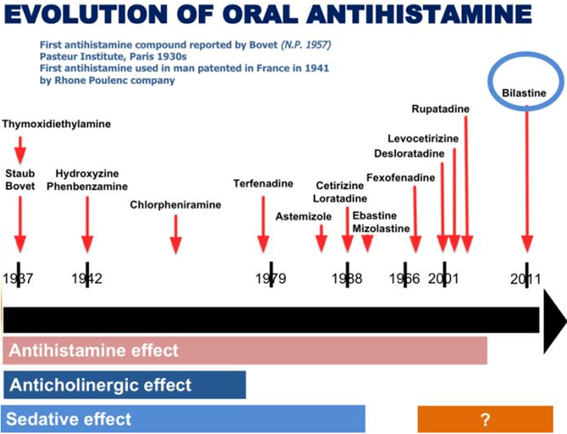
Figure 5. Evolution of Oral Antihistamine.

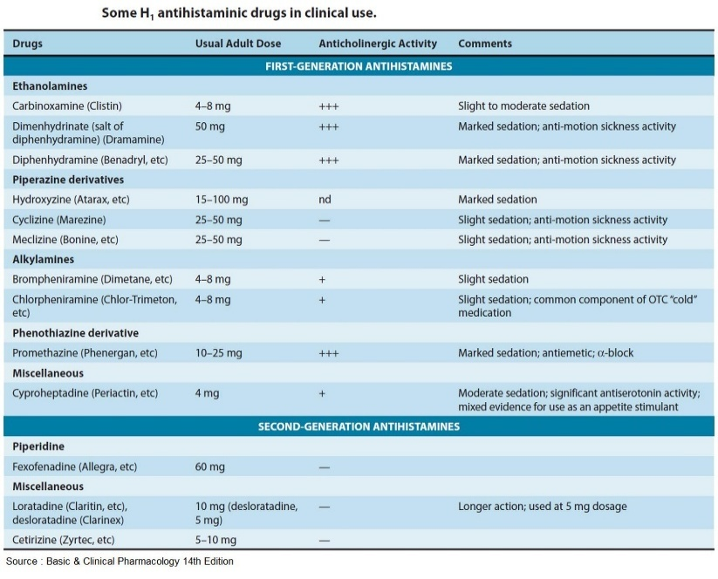
Figure 5. H1 Antihistaminic drugs in clinical use

DIPHENHYDRAMINE
- Oldest first-generation antihistamine and the oldest in the market.
- Side effects: HIGHLY SEDATING.
  - Autonomic receptor blocking effects (because of the similarity of the autonomic and histamine receptor) = hypotension and cardiac effects.

CHLORPHENAMINE, CYCLIZINE
- Prototype of new members of 1st generations.
- Side effects: LESS SEDATING.
  - Less autonomic effects: hypertension, tachycardia, ventricular arrhythmia.

SIGNIFICANT SIDE EFFECTS OF FIRST GENERATION ANTIHISTAMINES
1. Blockade of cholinergic receptors | Dry mouth  Blurring of vision  Urinary retention
2. Blockade of alpha-adrenergic receptors | Hypertension  Tachycardia
3. Blockade of serotonin receptors | Increased appetite
Table 5. Significant Side Effects of First-Generation Antihistamines
POSITIVE SIDE EFFECT OF 1ST GENERATION H1 ANTIHISTAMINES
Blockade of the central Histamine and Acetylcholine receptors | Antiemetic and anti-nausea effects
Brompheniramine  Chlorpheniramine  Clemastine  Cyproheptadine  Diphenhydramine (Benadryl) | Doxylamine  Hydroxyzine (Iterax)  Meclizine (Bonamine)  Promethazine
Table 6. Positive side effect of 1st generation H1 Antihistamines
NOTE: Always inform the side effects of the drug to the patient
and the proper duration of intake of the drug.

FIRST GENERATION ANTIHISTAMINES
Brompheniramine | - Half-life: 4-12 hours (older) vs 12-24 hours (newer).  - Metabolism: Most extensively metabolized in the liver.  - Route: Oral, Topical (Eye drops, nasal spray), Intravenous (1st generation).
Chlorphenamine
Clemastine
Cyproheptadine
Diphenhydramine
(Benadryl tablet and IV)
Doxylamine
Hydroxyzine
(Iterax tablet and IV)
Meclizine
(Bonamine chewable and non-chewable tablet)
Promethazine
Table 7. 1st generation Antihistamines

REMEMBER!
Though all these drugs are useful in relieving allergy symptoms, some of them are used for other therapeutic indications:
Diphenhydramine & Doxylamine:
Insomnia (Sedating and may have a “hang-over effect”).
Meclizine & Promethazine:
Motion sickness to control nausea and vomiting.

Can be used by pregnant women.

B2. | SECOND GENERATION H1
- Bulkier and less lipophilic structure
- Do not cross the blood-brain barrier as readily as the 1st generation.
- More selective for the peripheral H1 receptors involved in allergies as opposed to H1 receptors in the CNS.
- Provide relief for allergic symptoms with less side effect such as sedation.
- Includes drugs that have both antihistamine and mast cell stabilizing effects
  - Azelastine and Olopatadine – nasal and ophthalmic preparations.
  - Ketotifen (ophthalmic preparation only) for allergic rhino conjunctivitis.

MENMONICS: “CaLL D FBi, siR”
- Cetirizine (Zyrtec)  - Levocetirizine (Zyxal)  - Loratadine (Claritin)  - Desloratadine (Clarinex) | - Fexofenadine (Allergra)  - Bilastine (Bilaxten)  - Rupatadine (Rupafin)
Oldest: Cetirizine, Loratadine
After few years is the development of their L- enantiomers: Levocetirizine and Desloratadine.

SECOND GENERATION ANTIHISTAMINES
 | EXAMPLE | DOSE
Piperidine | Fexofenadine (Allegra) | 60mg
Miscellaneous | Loratadine (Claritin) | 10mg  (longer action)
 | Desloratadine (Clanex) | 5mg
 | Cetirizine (Zyrtec) | 5mg-10mg
Table 8. 2nd generation Antihistamines
- Generic preparation is available in the market that are equally effective
- Less side effects and there is condition that they are approved to double or quadruple the dose like in chronic urticaria.
- However, the more they increase the dose the more potential it could cause sedation.
- The better once are Fexofenadine and Bilastine: which are tested for F1 riders and for astronauts with urticaria and they seem okay and does not experience sedation.

B3. | H2 RECEPTOR BLOCKER
- Primary target is the acid producing cell in the stomach.
- Parietal cells have 3 types of receptors which control acid production.
- ACETYLCHOLINE RECEPTOR
- interacts with acetylcholine release from the GI tract through the parasympathetic vagus nerve activity → Increase intracellular Calcium.
- GASTRIN RECEPTOR
- Interacts with gastrin, produced by the G cells in the pyloric glands → Increase intracellular Calcium.
- Interacts with the nearby Enterochromaffin-like cells (ECL) to synthesize and secrete histamine.
- HISTAMINE 2 RECEPTOR
- Interacts with histamine → activate adenyl cyclase → increase intracellular cAMP levels.
- Increase in IC cAMP and Ca⁺ → activation of protein kinase → stimulate hydrogen potassium ATPase.
- This gastric proton pump secretes hydrogen ions into the lumen of the stomach in exchange for potassium.
- Selectively block H2 Receptor sites thus effectively reducing the secretion of gastric acid.
- Clinical application: Treatment of Gastric Ulcers and GERD.

MNEMONICS: “FRaNCe”
Famotidine (Pepcid)
Nizatidine (Axid)
Ranitidine (Zantac)
Cimetidine (Tagamet)
CAUTION!
Watch out for drug-drug interaction and side effects of CIMETIDINE like Gynecomastia and Galactorrhea due its antiandrogenic and prolactin stimulating effects.

- Generally, are more tolerated; few and mild adverse effects – headache
- Provide negative feedback that will reduce histamine release from mast cells when the body produces too much histamine.
- Also has cardiac stimulant effect
- Actions are mediated by activation of Adenylyl cyclase, which increases intracellular cAMP.

B4. | H3 RECEPTOR BLOCKER
- Found at the nerve endings in the CNS.
- Responsible for presynaptic modulation of histaminergic neurotransmission in the CNS.
- In the periphery, it appears to be a presynaptic heteroreceptor with modulatory effect in the release of other transmitters.
- Food intake and body weight increases H3 Receptor knockout in animals; selective H3 agonist are being studied for appetite suppression.
- No studies on human are available yet; drugs under H3 receptor blockers are not yet being clinically used.

B5. | H4 RECEPTOR BLOCKER
- Usually found in WBC (leukocytes), CD4 T- cells, and involved in the chemotaxis of these cells.
- Usually on leukocytes (especially eosinophils) and Mast cells.
- Gi coupled.
- No known clinical application yet for these drugs.

- OTHER CLINICAL APPLICATION OF ANTIHISTAMINE
- Anti-motion sickness drugs (antiemetic effect), especially the First generation H1 blockers.
- Many are also potent local anesthetics and can be used to patients allergic to conventional Anesthesia.
- Example: Promethazine
- Can be exploited to be used therapeutically to counter sleeping tablets (e.g., Diphenhydramine) because of low dependency potential.

- SEROTONIN AND TREATMENT FOR DEPRESSION
- SEROTONIN
- AKA: 5- Hydroxytryptamine (5-HT); Substance for happiness and well- being
- Important Neurotransmitter; a local hormone in the gut.
- Feeling good: serotonin levels are okay
- Feeling down: serotonin levels are down
- Stored in vesicles (in the enterochromaffin cells of the gut and the neurons of the CNS and the enteric nervous system).
- Produced in the specialized neurons from extensive serotonergic pathways that reach almost any part of the CNS (including cerebellum and spinal cord).
- Implicated in a vast array of brain functions, including sleep and wake cycle, appetite, mood regulation, memory and learning, temperature control, etc.
- When a person is happy, he/she is able to learn faster and retain memory longer as compared with sad state.

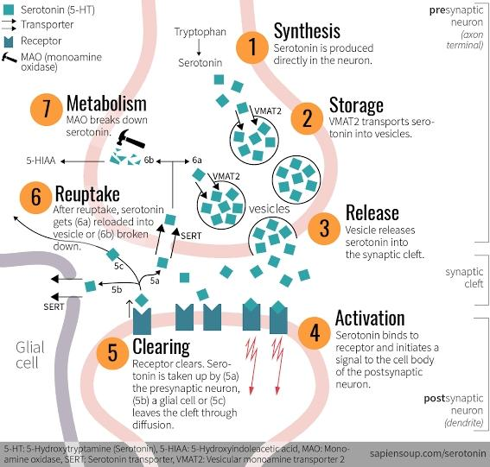
Figure 6. Life Cycle of Serotonin.
Step 1: Synthesis (Presynaptic neuron: axon terminal) Tryptophan→ Serotonin. Serotonin is produced directly in the neuron. Step 2: Storage (Presynaptic neuron: axon terminal) VMAT2 transports serotonin into vesicles. Step 3: Release (Synaptic cleft) Vesicles release serotonin into the synaptic cleft. Step 4: Activation (post-synaptic neuron: dendrites) Serotonin binds to receptor and initiates a signal to the cell body of the postsynaptic neuron. Step 5: Clearing: Receptor clears; Serotonin is taken up by the presynaptic neuron, a glial cell or leaves the cleft through diffusion. Step 6: Reuptake After reuptake, serotonin gets reloaded into vesicle or broken down. Step 7: Metabolism. MAO breaks down serotonin

- A component of the platelet clotting process, and is thought to play a role in migraine headache and several other clinical conditions, including carcinoid syndrome (is an unusual manifestation of carcinoid tumor, a neoplasm of enterochromaffin cells).
- In patients whose tumor is not surgically resectable, a serotonin antagonist may constitute a useful treatment.

- SEROTONIN SYNTHESIS AND METABOLISM
- Serotonin is synthesized from amino acid (AA) tryptophan and is stored in small vesicles within the nerve terminal.
- When a serotonergic neuron is stimulated, Serotonin is released into the synaptic cleft where it binds to and activates Serotonin receptors on the post synaptic space by Serotonin transport protein.

- SEROTONIN IN RELATION TO DEPRESSION
- Low levels of Serotonin in the brain have been associated with depressive disorders.
- Current treatment of depression targets to elevate these levels.

- SELECTIVE SEROTONIN REUPTAKE INHIBITOR (SSRIs)
- Most commonly prescribed drug in depression.
- Mechanism of Action: Act by blocking reuptake by the transmitting neurons → resulting in elevated levels of serotonin in the synaptic space and its prolonged action on the receiving neurons.
- Ideal drug of choice for depression because they produce fewer side effects due to their selective action on serotonin alone and no other neurotransmitters.

MNEMONIC “CE-pram/ FluParoSer-tine”
Citalopram (Celexa)
Escitalopram (Lexapro)
Fluoxetine (Prozac)
Paroxetine (Paxil, Pexeva)
Sertraline (Zoloft)
CAUTION!
Serotonin activity in the brain is widespread, watch out for “Serotonin Syndrome”.

D1. | Serotonin Syndrome
- Generally caused by a combination of 2 or more drugs used to raise serotonin levels in the brain.
- If the medication is not discontinued, the condition becomes fatal.
- The hallmark Signs and Symptoms:
- Anxiety
- Restlessness
- Diaphoresis
- Mydriasis
- Clonus
- Hyperreflexia
- Tachycardia
- Hypertension
- Management:
  - Supportive care
  - Intravenous fluids
  - Benzodiazepines titrated for symptom control
  - Blood pressure control

- NON-PHARMACOLOGIC INTERVENTIONS
- Positive mood induction, either self- induced or due to psychotherapy.
- Interaction between serotonin synthesis and mood may be two- way.
- Other modalities:
- Exposure to bright light/sunlight (Thus, people exposed to prolonged darkness (Europe) are prone to developing depression)
- Diet with tryptophan – rich foods
- Exercise - most effective and safest means to improve mood
- Self-love activities such as spa.

CASE STUDY:
General date: B.A 7/M, consulted due to sneezing.
History of Patient Illness: The patient was apparently well until 2-month PTC the patient was noted to have episodes of rhinorrhea associated with nasal itching and sneezing. These episodes would occur 3 days a week bur does not affect his sleep or school. Due to the persistence of symptoms, consult was done. • Family Medical History: (+) Maternal history of bronchial asthma; (+) shrimp allergy of older sibling.
Nutritional History: Breastfed for 1 week only then shifted to formula feeding.
Social & Environmental History: Lives with both parents and older sister; 1 indoor pet dog (labrador).
Pertinent PE findings: Bluish infraorbital skin, with Dennie-Morgan lines, (-) tearing, (-) periorbital edema, (-) nasal septal deviation, (+) transverse nasal crease, chapped lips, moist mucus membrane, (-) lymphadenopathies.
Anterior rhinoscopy: clear discharge, with boggy, bluish-gray swollen turbinate noted bilaterally.
Equal chest expansion: (-) retractions, clear breath sounds.

Diagnosis: Allergic Rhinitis: IgE-mediated reaction, usually caused by sensitization to inhaled allergens
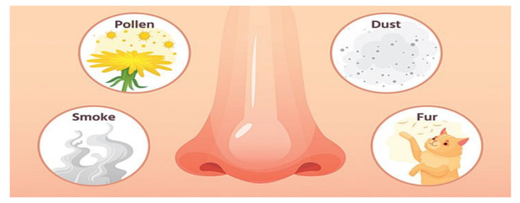
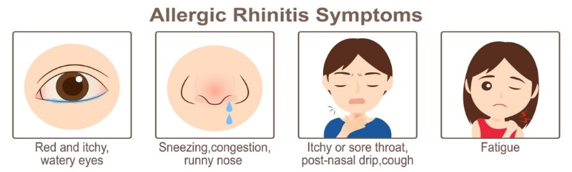

ARIA CLASSIFICATION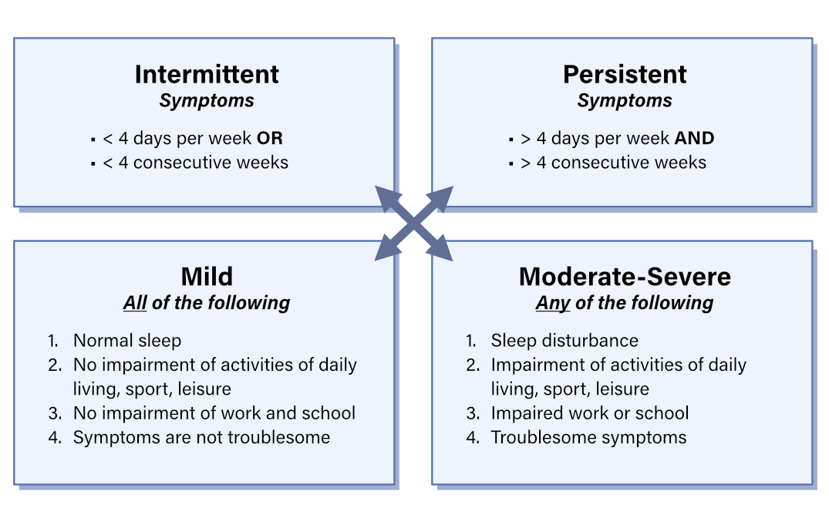

- Is the history and physical examination suggestive or allergic rhinitis?
- The body part that is reacting is the lining of the nose.
- We classify allergic rhinitis using the ARIA classification, a guideline how to manage your patients.
- The patient has an onset of 2-month PTC; however, it is not daily which is classified as intermittent and having a mild sign and symptoms due to normal sleep and symptoms are not troublesome.
- Mild Intermittent Allergic Rhinitis.
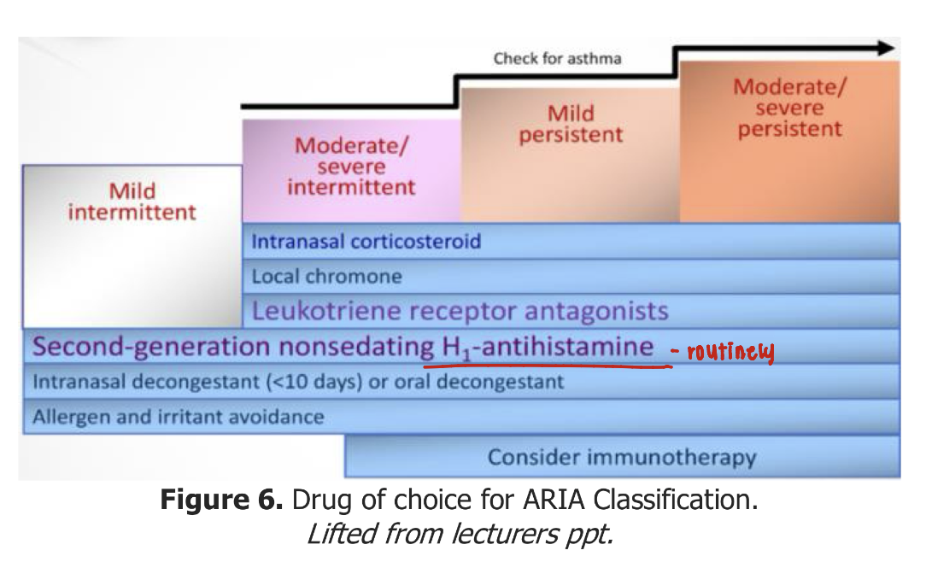
- Knowing this classification, we will be able to manage your patients.
Management of Allergic Rhinitis
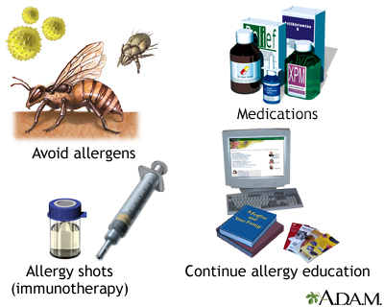
- If the patient is Mild intermittent, the drug of choice is the second-generation nonsedating H1-antihistamines
- If a patient has moderate to severe intermittent or persistent, the 1st line is intranasal corticosteroid

- INTRODUCTION TO SEROTONIN
- SEROTONIN (5-HYDROXYTRYPTOPHAN)
- C₁₀H₁₂N₂O
- Site of production:
- Brain
- Gut
- Controls:
- Mood
- Memory
- Sleep
- Cognition
- Excess 5-HT:
- Serotonin syndrome leading to diarrhea, muscle rigidity, fever, seizures
- Deficient 5-HT:
- Irritability
- Aggression
- Depression
- Insomnia
- Activities that boost levels of serotonin.
- Smiling
- Exercising
- Sunshine
- Eating well

- RECEPTOR AND SUTYPES
- Histamines ONLY have ANTAGONISTS.
- Clinical application for serotonin involves BOTH AGONIST and ANTAGONISTS.
- There are 15 identified serotonin receptors presently.
- Serotonin agonists will act on:
  - 5-HT1D/1B
  - 5-HT2
  - 5-HT4
- Serotonin antagonists currently in use or under investigation will act on:
  - 5-HT2
  - 5-HT3

RECEPTOR SUBTYPE | DISTRIBUTION
H1 | Smooth muscle, Endothelium, Brain
H2 | Stomach, Heart, Muscle, Brain, Mast cells
H3 | Nerve endings, CNS
H4 | Leucocytes, CD4 T-cells
5-HT A, B, D | Brain
5-HT2 | Brain, Smooth muscles, Platelets
5-HT 3 | Area postrema (CNS), Sensory and enteric nerves
5-HT4 | Presynaptic nerve terminals in the enteric nervous system
Table 9. 5-HT Receptor Subtypes
B1. | 5-HT1 RECEPTORS
- Most important in the brain and will mediate synaptic inhibition via increased K+ conductance.

B2. | 5-HT2 RECEPTORS
- Important in both the brain and the peripheral tissues and will mediate synaptic excitation in the CNS and smooth muscles contraction (gut, bronchi, & uterus).
  - Several mechanisms involved such as increased IP3, decreased K+ conductance, increase cAMP.
  - This receptor will mediate some of the vasodilation, diarrhea, and bronchoconstriction that are signs of carcinoid tumor.
- Carcinoid tumor is a neoplasm that secretes serotonin.

B3. | 5-HT3 RECEPTORS
- Found in CNS (especially in the chemoreceptive area and vomiting center) in the peripheral, sensory, and enteric nerves.
- Mediate excitation via the 5-HT gated cation channels.
- Antagonist acting on these receptors are very useful anti-emetic drugs.
B4. | 5-HT4 RECEPTORS
- Found in the GIT and will play a role in intestinal motility.

- SEROTONIN AGONISTS

RECEPTOR | DRUGS
5-HT 1D/1B Agonists | Sumatriptan (Imigran)  Naratriptan (Nartan) | - 1st line treatment for ACUTE MIGRAINE & CLUSTER HA ATTACKS  - Oral, Nasal Parenteral routes
5-HT2C Agonists | Lorcaserin (Belviq) | - Approved for the treatment of OBESITY (Moderately reduces appetite)  - Presently discontinued because the FDA found a possible CA risk, hallucinogen at higher does and psychiatric dependence
 | Fenfluramine (Fintepla)  Dexfenfluramine (Redux) | - Withdrawn from the market: association with pulmonary hypertension and heart disease
5-HT4 Partial Agonist | Tegaserod  (Zelnorm & Zelmac) | - Newer drug: act as agonist in the colon  - Approved and briefly marketed for use in chronic constipation but cardiovascular toxicity (heart attack and stroke) hence is restricted.
Table 9. 5-HT Agonists
C1. | 5-HT AGONISTS: PRECAUTIONS HYPERTHERMIA SYNDROMES

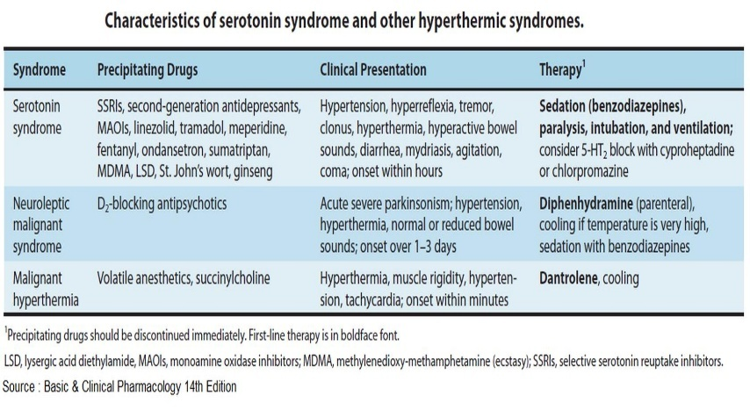

- SEROTONIN ANTAGONISTS

RECEPTOR | DRUGS | MECHANISMS & EFFECTS | CLINICAL USE
5-HT2 | Ketanserin (Sufrexal) | Competitive pharmacologic 5-HT2 antagonists  Poorly selective agents | Antihypertensive  Treatment of Carcinoid syndrome
 | Cyproheptadine  (Periactin) |  | Treatment of Carcinoid syndrome
 | Phenoxybenzamine (Dibenzyline & Dibenyline) |  | Treatment of Carcinoid syndrome
5-HT3 | Ondansetron (Zofran & Zuplenz) | Selective 5-HT3 receptor blockers | Antiemetic  Control of post op vomiting and vomiting associated with CA chemotherapy
 | Graniesetron (Kytril, Sancuso, Sustol) |  | Antiemetic
 | Dolasetron (Anzemet) |  | Antiemetic
 | Alosetron (Lotronex) |  | Treatment of IBS  S/E: Significant constipation and may lead to fatal bowel complications

- ERGOT ALKALOIDS
- Produced by a fungus (Claviceps purpurea) in wet or spoiled grain.
- Fungus synthesized histamine, ACh, tyramine, and other biologically active products in addition to a score or more of unique ergot alkaloids.
- Responsible for the epidemics of “St. Anthony’s Fire” (Ergotism / Ergot poisoning).
- There are 20 naturally occurring members of the family, only a few are used.
- Partial agonist at alpha adrenoceptors, 5-HT receptors, and some are potent agonist at dopamine receptors.
- Aside from the naturally occurring ergots, semi-synthetic derivatives are now also used.

- CLASSIFICATION AND EFFECTS
- Divided into 3 major subgroups on the basis of the organ or tissue on which they have their primary effects.

A1. | BLOOD VESSELS
- Ergot alkaloids can produce marked and prolonged alpha adrenoceptor mediated vasoconstriction.
- Prototype: ERGOTAMINE (Ergomar®, Cafergot®, & Migergot®)
- Oral route

A2. | UTERUS
- Powerful contractions, especially near term.
- Prototype: ERGONOVINE (Ergotrate®, Ergostat®, Syntometrine®)
- In pregnancy the uterine contraction is sufficient to cause abortion or miscarriage, however, earlier in the pregnancy and the non-pregnancy uterus, much higher doses or ergot alkaloids are needed to cause contraction.
- Via oral, intramuscular, and intravenous routes.

A3. | BRAIN
- Hallucinations in naturally occurring ergots; uncommon in the therapeutic ergot derivatives.
- Prototypes: BROMOCRIPTINE & PERGOLIDE
- Act as D2 agonists in the Pituitary and Basal Ganglia; they are among the 7 most potent semi-synthetic ergot derivatives.

- CLINICAL USES
B1. | MIGRAINE
- Ergotamine has been a mainstay of treatment used in combination with caffeine.
- Methysergide, dihydroergotamine, and ergonovine have been used for prophylaxis.
- Drug of choice: Triptan (SUMATRIPTAN)
- Derivatives are more preferable than ergots because of lower toxicity than ergots.

B2. | OBSTETRIC BLEEDING
- Ergonovine and Ergotamine are effective agents for the reduction of postpartum bleeding.
- They produce a powerful and long-lasting contraction what will reduce bleeding however they must not be given before delivery of the placenta.
- Must wait for the placenta to go out before giving Ergotamine.

B3. | HYPERPROLACTINEMIA AND PARKINSONISM
- Bromocriptine, Peroxide, and Cabergoline.
- They are used in the treatment of Parkinson’s disease, but they are not the drug of choice.
- Levodopa is the drug of choice for Parkinson’s disease.
- Used to reduce prolactin secretion in hyperprolactinemia and acromegaly (off-label use).

- TOXICITIES
C1. | PUBLIC HEALTH STANDPOINT
- Epidemics of ergotism from spoiled grain (intense pain and cold in the extremities due to vasoconstriction followed by intense burning sensations, pain, distal necrosis, hallucinations, and convulsions).
- Overuse or abuse
- Can lead to toxicity especially LSD

C2. | VASCULAR EFFECTS
- Severe prolonged vasoconstriction can result in ischemia and gangrene.
- Antidote: NITROPRUSSIDE
- Unusual hyperplasia of connective tissue
- This fibroplasia maybe retroperitoneal, retro pleural, or subendocardial and can cause hydronephrosis or cardiac valvular and conductive system malfunction.

C3. | CNS EFFECTS
- Hallucinations: common with LSD but less with ergot alkaloids.

- REFERENCES
Dra. Tolentino’s PowerPoint
Vanderah, T. W. (2023). Katzung’s Basic and Clinical Pharmacology, 16th Edition. McGraw Hill Professional.

